HD 26161

HD 26161 is a 1.13 M☉, G0 star1. Using 50 RV HIRES measurements obtained between 1998 and 2019 and 84 RV Apf measurements obtained between 2019 and 2020, the CL survey reported a LPGP with a period of ${32000}_{-10000}^{+21000}$ days, a minimum mass of ${13.5}_{-3.7}^{+8.5}$ MJup and an eccentricity of ${0.82}_{-0.05}^{+0.061}$.

In the present study, the CL survey's dataset was used. DPASS and MCMC (1000 walkers, 400000 iterations, prior for *a* between 0 and 1000 au, prior for the RV offset between -1 and 1 km/s, prior for the eccentricity between 0 and 0.99) were first used to fit the data. A companion with a period of 64224 days, a minimum mass of 14.1 MJup and an eccentricity of 0.78 were found with DPASS, with a corresponding rms of residuals of 6.3 m/s. With the MCMC, solutions with a period peaking at about 100 yrs and extending to more than 300 yrs (peak of *a* at about 14 au, extending to more than 30 au), a minimum mass between 13 and 170 MJup and an eccentricity larger than 0.75 were found. The fits are shown in Figure 1 and 2, and the results summarized in Table 2.

Yet, as no extremum is covered with the present dataset, the stellar offset, and therefore the companion orbital properties, are not well constrained. To explore the impact of the RV offset on the results of the genetic algorithm, the RV offset was fixed to arbitrary values (yet compatible with the range of published values) and the data were fitted with DPASS. It appeared that fixing the RV offset at values up to 300 m/s leads to solutions with rms of residuals very close to that obtained with a free offset. For instance, with an RV offset of 300 m/s, a semi-major axis of 42 au, a minimum mass of 80 MJup and an eccentricity of 0.66 were found, associated with an rms of 7.2 m/s.

A similar exercise was done fixing various semi-major axes and similar conclusions were reached (see Table 1). It appeared that with *a* up to 240 m/s, solutions giving rms of residuals within 1m/s from the baseline (7 m/s) were obtained. An example is shown in Fig. 1.

The impact of the RV offset or the semi-major axis on the MCMC results was then checked. A new MCMC sampling was performed fixing the RV offset at 300m/s. The prior on *a* was again very loose, 0 to 1000 au. The *a* distribution peaked at about 45 au, significantly higher than in the case where the RV offset was free. The best likelihood was, however, only slightly lower than that obtained with a loose prior on the RV offset, and the distributions of the likelihoods overlapped (Fig. 3).

As a second test, the prior on the *a* was constrained to 240-300 au. As expected, the distribution of *a* sampled by the MCMC (see Fig. 4) was truncated at the min value, 240 au, but the distribution of likelihoods overlapped with the one obtained with very loose priors for the *a* in the range 0-1000 au. Hence, some solutions sampled with *a* in the range 240-300au provide likelihoods identical to those sampled with loose priors on *a*. These solutions are equally likely, but the MCMC did not capture them when the priors on *a* were very loose.

Note that, recently, combining RV and Hipparcos/Gaia absolute astrometry data, a study performed in 20222 (hereafter F22) were able to estimate the orbital inclination, and thus the true mass of HD 26161b. They found a period of ${10942.3}_{-1387.9}^{+10474.1}$ days, an eccentricity of ${0.922}_{-0.099}^{+0.037}$, an inclination of ${59.558}_{-30.662}^{+50.850}$ °, and a mass of ${28.460}_{-0.222}^{+20.049}$ MJup. Yet, as the available RV data do not allow to properly constrain the properties of HD 26161b. The uncertainties obtained on the period of the planet are probably underestimated, as for the CL survey solution. The true mass estimated by F22 can therefore not be confirmed.

Conclusion: The orbital properties and the mass of HD 26161b found in the CL survey are not confirmed. Depending on its semi-major axis, the companion could well be a brown dwarf. Additional data are needed to further constrain its orbital properties.

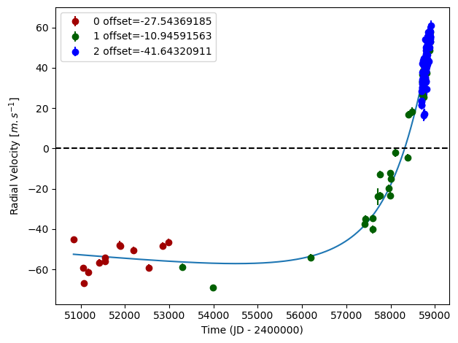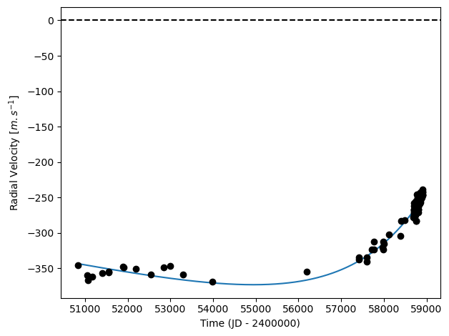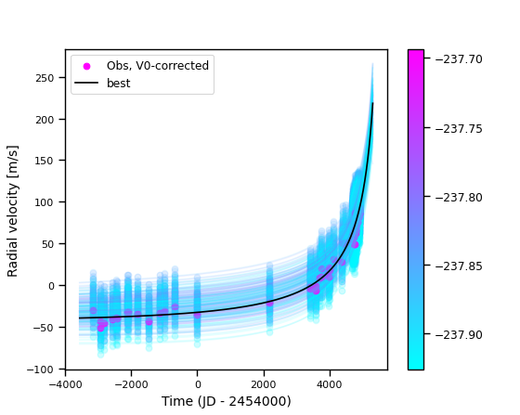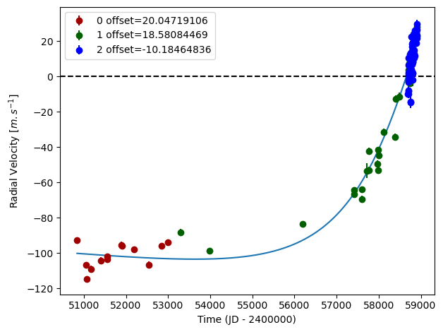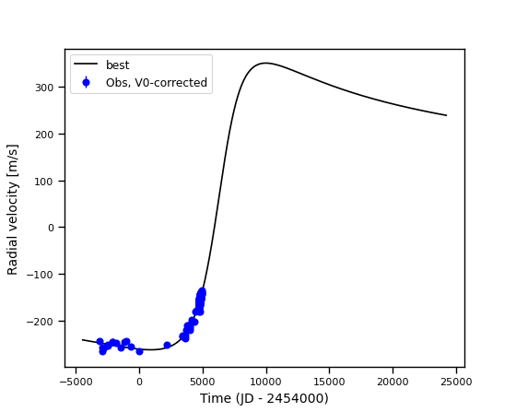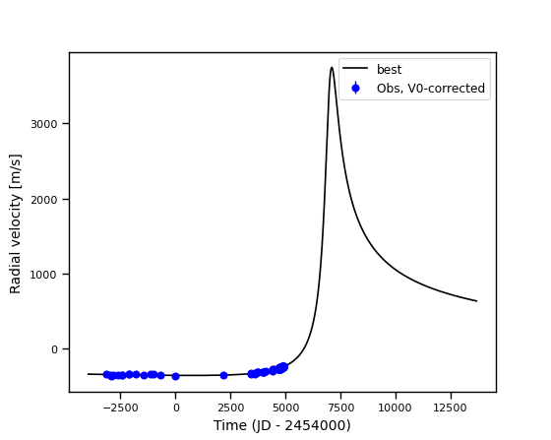

Figure 1: Top left: fit of the HD 26161 RV with DPASS. Red – Hir94; green – Hir04; blue – APF. The blue curve shows the best fit. Top right: fit of the HD 26161 RV using MCMC. The black curve shows the best fit. The colorbar corresponds to the log-likelihood of the fits. Middle left: fit of the HD 26161 RV with DPASS, with a subtracted stellar offset fixed to 300 m/s. Black points correspond to the data corrected from the instrumental offsets. The blue curve shows the best fit. Middle right: best fit of the HD 26161 RV using MCMC, with a subtracted stellar offset fixed to 300 m/s. The black curve shows the best fit. Bottom Left: fit of the HD 26161 RV with DPASS, with the minimum *a* fixed at 240 au. The points are the same as on the top left. The blue curve shows the best fit. Bottom right: best fit of the HD 26161 RV with MCMC, with a prior on *a* in the range 240-300au. The black curve shows the best fit.

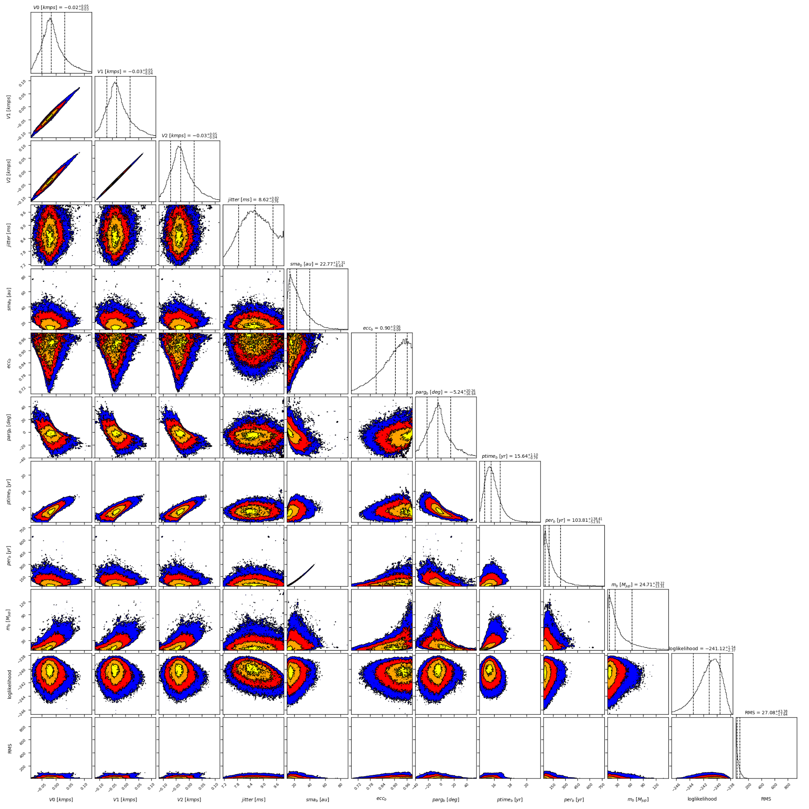

Figure 2: Corner plot of posteriors for the one-planet model MCMC fit of HD 26161 RV data with loose priors on the RV offsets and on semi-major axes.

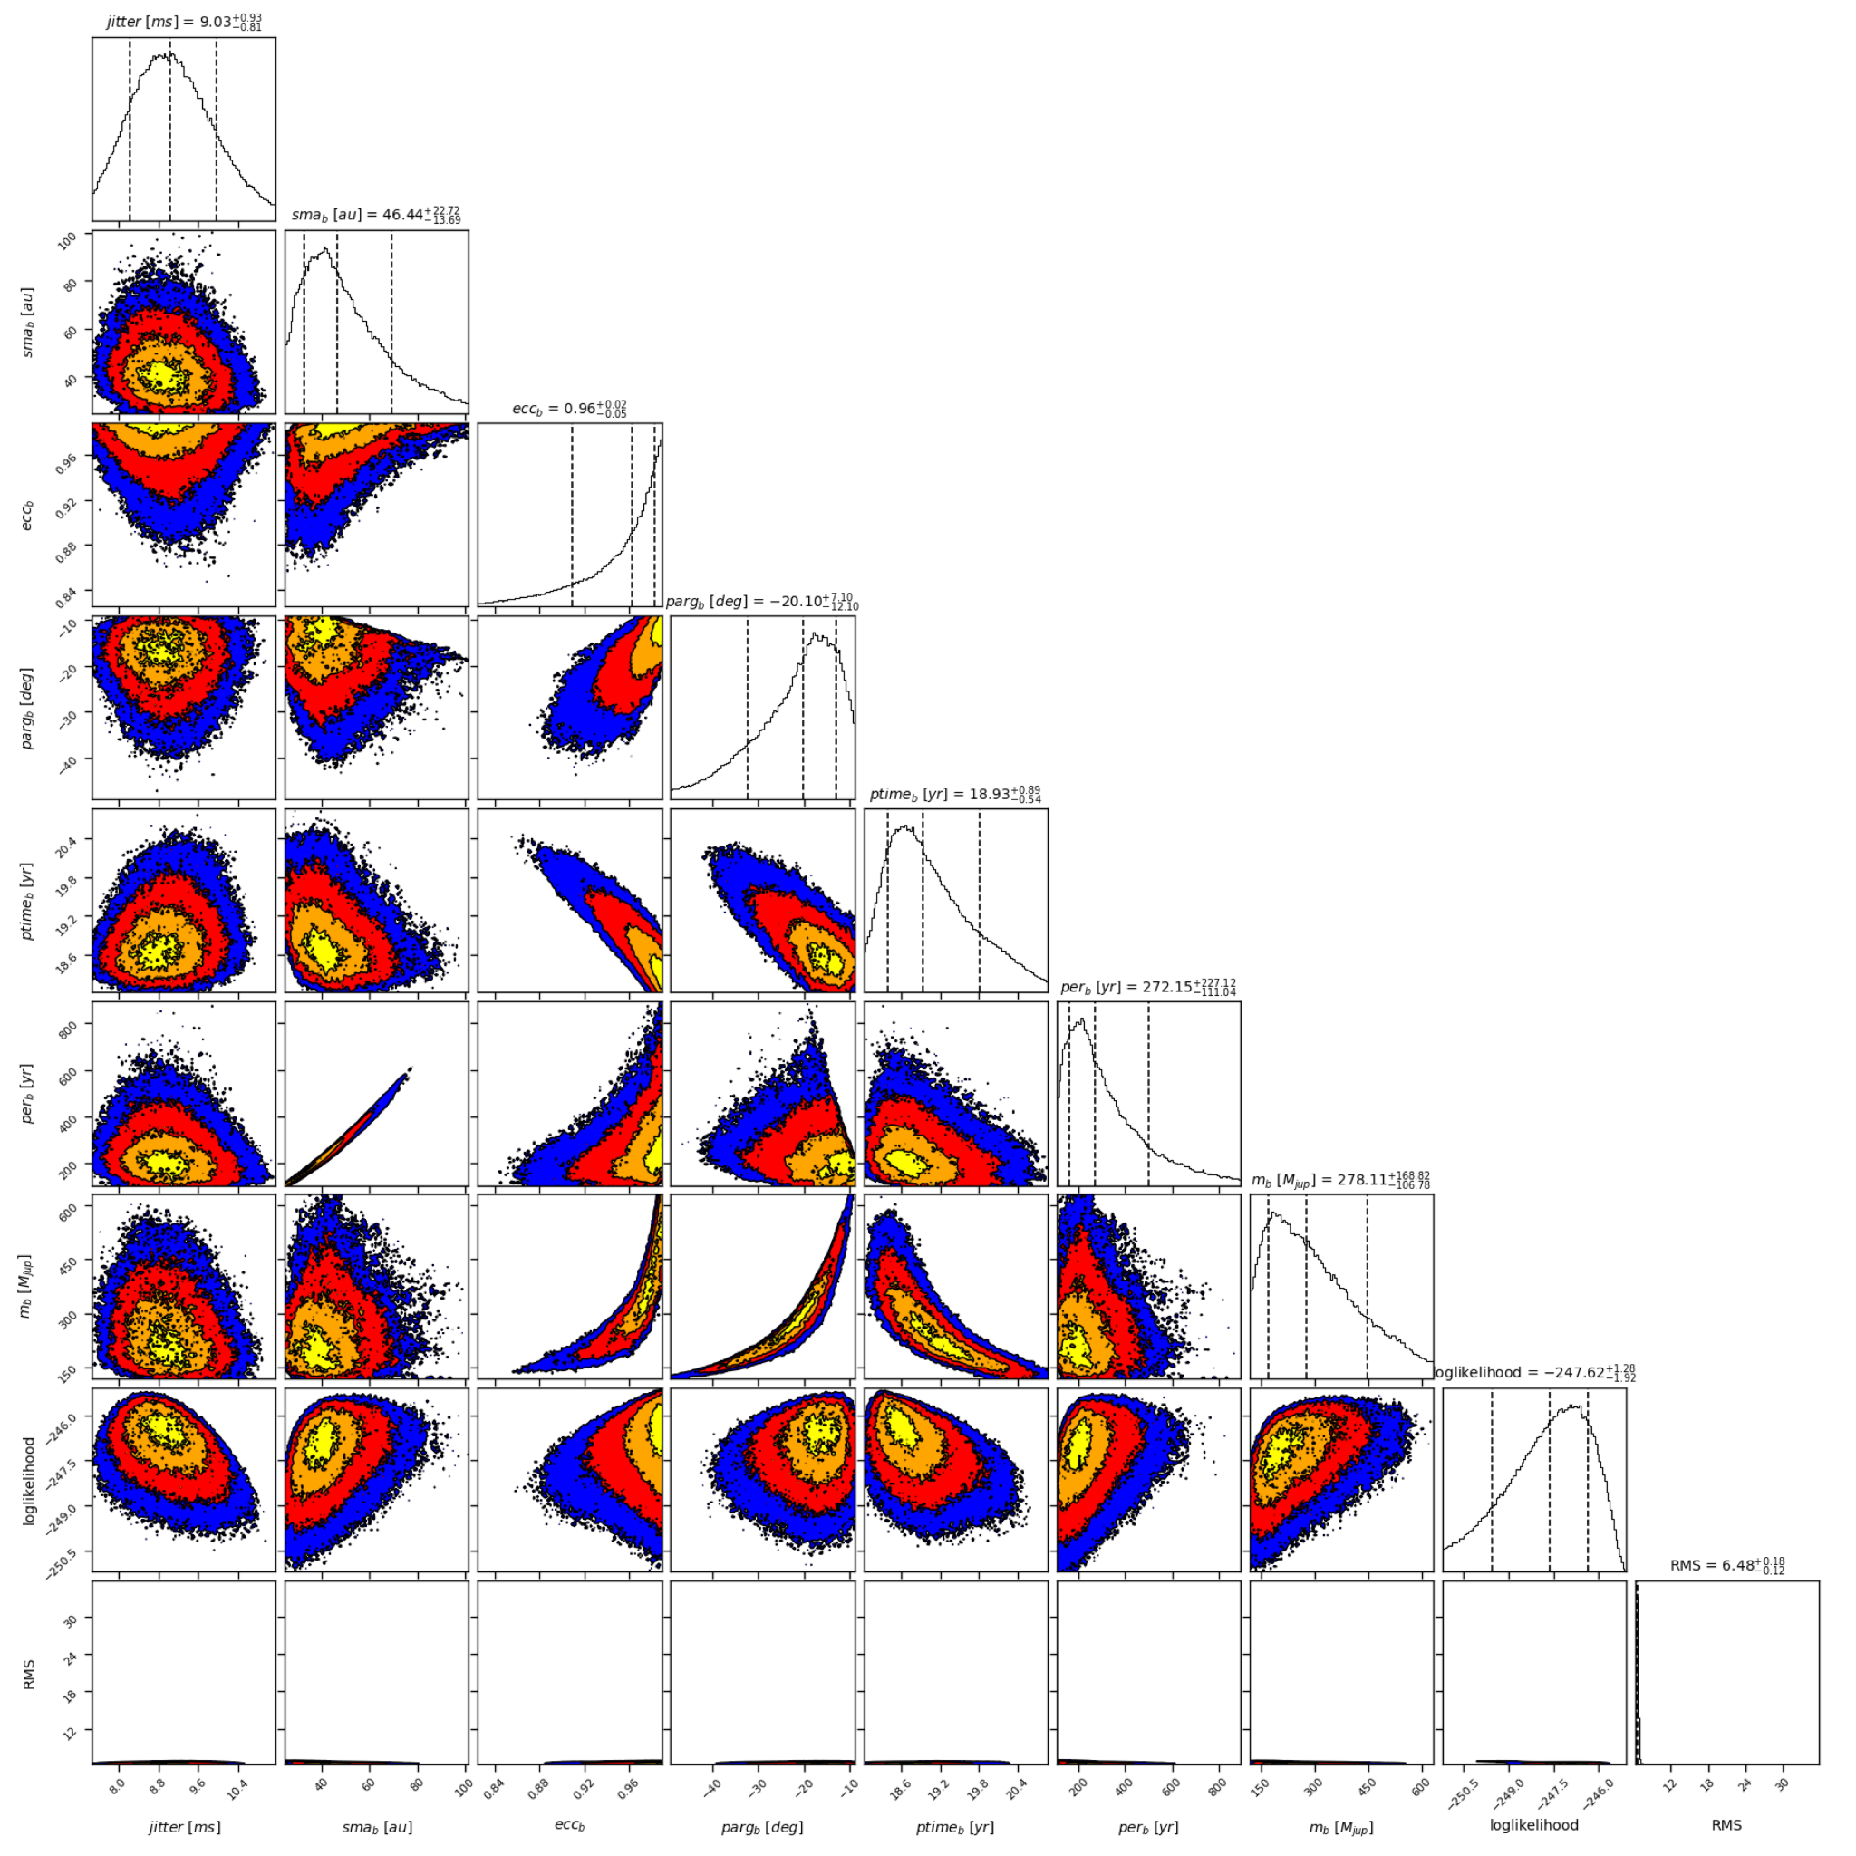

Figure 3: Corner plot of posteriors for the one-planet model MCMC fit of HD 26161 RV data with the RV offset fixed at 300m/s.

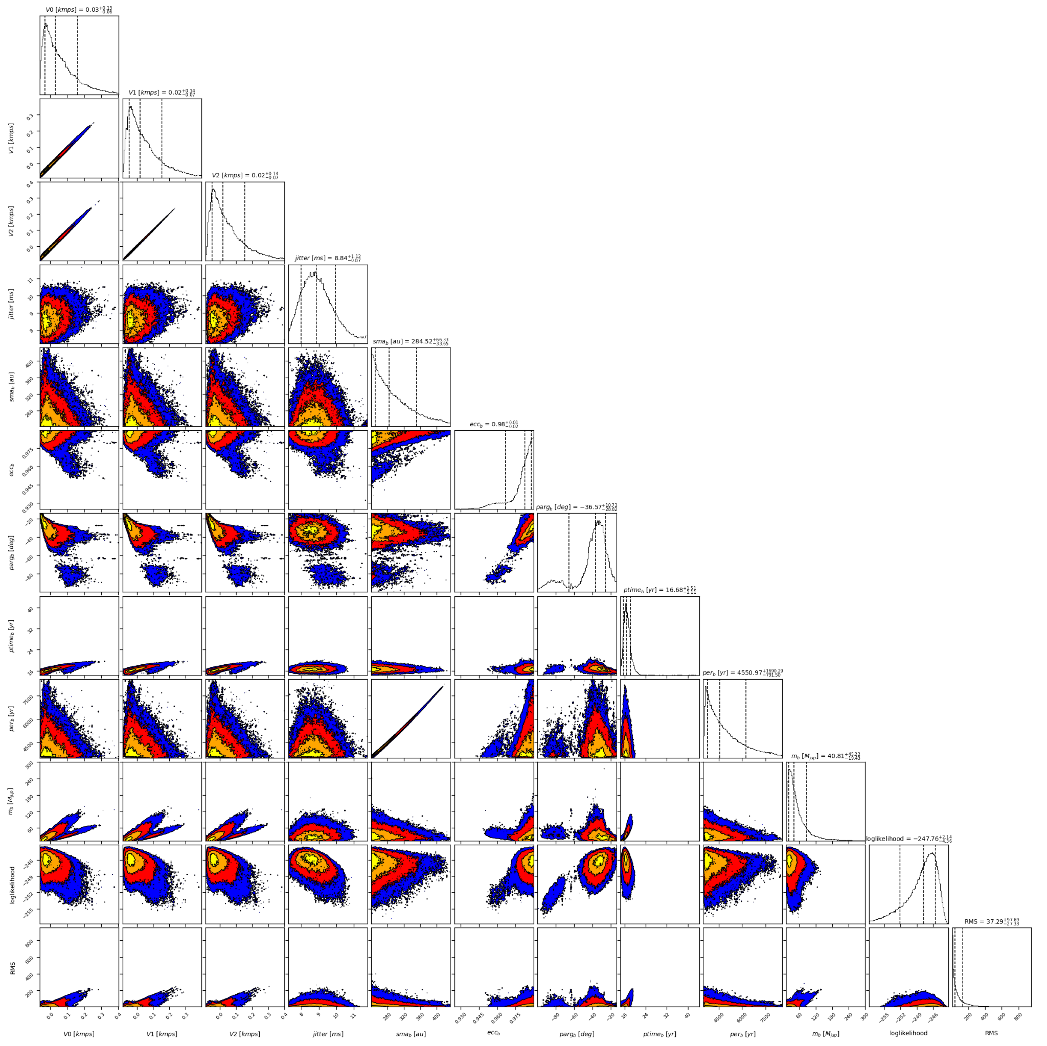

Figure 4: Corner plot of posteriors for the one-planet model MCMC fit of HD 26161 RV data with a prior on *a* in the range 240-300au.

| Parameter | Priors | | | Posteriors | | | CL survey |
| --- | --- | --- | --- | --- | --- | --- | --- |
|  | Free offset | Constrained offset | Constrained sma | Free offset | Constrained offset | Constrained sma |  |
| sma (au) | [0,100] | [0,100] | up to 240 | 33 | 42 | 240 | ${20.4}_{-4.9}^{+7.9}$ |
| Msin(i) (MJup) | [0,100] | [0,100] | [0,100] | 14.1 | 80 | 23 | ${13.5}_{-3.7}^{+8.5}$ |
| Eccentricity | [0,0.95] | [0,0.95] | [0,0.95] | 0.78 | 0.66 | 0.95 | ${0.82}_{-0.05}^{+0.061}$ |
| Instrumentals offsets (km/s) | [-60,60] | up to 0.3 | [-60,60] | Hir94: -0.028  Hir04: -0.011  Apf: -0.042 | 0.3 | Hir94: 0.020  Hir04: 0.019  Apf: -0.010 |  |
| Stellar jitter (m/s) | [0,40] | [0,40] | [0,40] | 8.8 | 10 | 9.7 |  |
| Argument of periastron (°) | [0,360] | [0,360] | [0,360] | 305 | 281 | 281 |  |
| Phase | [0,1] | [0,1] | [0,1] | 0.92 | 0.68 | 0.05 |  |

Table S2a: HD 26161. Summary of priors and posteriors obtained with DPASS, compared to the properties reported by the CL Survey.

| Parameter | Priors | | | Posteriors | | | CL survey |
| --- | --- | --- | --- | --- | --- | --- | --- |
|  | Free offset | Constrained offset | Constrained sma | Free offset | Constrained offset | Constrained sma |  |
| sma (au) | [1,1000] | [1,1000] | [240,1000] | 15 – 60 | 32 – 69 | 240 – 350 | ${20.4}_{-4.9}^{+7.9}$ |
| Msin(i) (MJup) | [1,1000] | [1,1000] | [1,1000] | 13 – 170 | 171 – 447 | 21 – 86 | ${13.5}_{-3.7}^{+8.5}$ |
| Eccentricity | [0,0.99] | [0,0.99] | [0,0.99] | > 0.75 | > 0.91 | > 0.96 | ${0.82}_{-0.05}^{+0.061}$ |
| Instrumentals offsets (km/s) | [-1,1] | up to 0.3 | up to 0.3 | Hir94: -0.056 – 0.081  Hir04: -0.076 – 0.072  Apf: -0.075 – 0.077 | Hir94: 0.3  Hir04: 0.3  Apf: 0.3 | Hir94: -0.033 – 0.160  Hir04: -0.047 – 0.155  Apf: -0.047 – 0.155 |  |
| Stellar jitter (m/s) | [0,10] | [0,10] | [0,10] | 8.0 – 9.9 | 8.2 – 9.9 | 8 – 9.9 |  |
| Argument of periastron (°) | [0,360] | [0,360] | [0,360] | 336 – 39 | 328 – 347 | 295 – 339 |  |
| Phase | [0,1] | [0,1] | [0,1] | 0.07 – 0.41 | 0.04 – 0.12 | 0.01 ± 0.01 |  |

Table S2b: HD 26161. Summary of priors and posteriors obtained with MCMC, compared to the properties reported by the CL Survey.

References

1. Rosenthal, L. et al. The California Legacy Survey. I. A Catalog of 178 Planets from Precision Radial Velocity Monitoring of 719 Nearby Stars over Three Decades. *Astrophys. J.* *Suppl. Ser.* 255, 8 (2021).
2. Feng, F. et al. 3D Selection of 167 Substellar Companions to Nearby Stars. *Astrophys. J. Supp. Ser.* 262, 21 (2022).